Read the following instructions before completing the given task.  
  
Step 1: Click on the Online Task Link

Step 2: Download the document

Step 3: Check the online questions

Step 4: Complete the task and take a screenshot for each and every task and upload

Step 5: Save the document

Step 6: Upload the document in Google form

* **AWS Account is mandatory to complete the tasks**.
* **Include AWS account Name in your screenshots**
* **Resume / Copied and similar tasks will be rejected directly.**

**Assignment 1.**

Configure ec2 linux machine and install apache configuration

[ec2-user@ip-172-31-86-93 ~]$ sudo su - root

[root@ip-172-31-86-93 ~]# hostname tomcat

[root@ip-172-31-86-93 ~]# bash

[root@tomcat ~]# sudo yum update

Loaded plugins: extras_suggestions, langpacks, priorities, update-motd

Resolving Dependencies

--> Running transaction check

---> Package ec2-hibinit-agent.noarch 0:1.0.2-7.amzn2 will be updated

---> Package ec2-hibinit-agent.noarch 0:1.0.8-0.amzn2 will be an update

---> Package kernel.x86_64 0:5.10.209-198.812.amzn2 will be installed

---> Package pam.x86_64 0:1.1.8-23.amzn2.0.1 will be updated

---> Package pam.x86_64 0:1.1.8-23.amzn2.0.2 will be an update

---> Package pcre2.x86_64 0:10.23-11.amzn2.0.1 will be updated

---> Package pcre2.x86_64 0:10.23-11.amzn2.0.2 will be an update

---> Package python-jinja2.noarch 0:2.7.2-3.amzn2 will be updated

---> Package python-jinja2.noarch 0:2.7.2-3.amzn2.0.1 will be an update

---> Package systemd.x86_64 0:219-78.amzn2.0.22 will be updated

---> Package systemd.x86_64 0:219-78.amzn2.0.23 will be an update

---> Package systemd-libs.x86_64 0:219-78.amzn2.0.22 will be updated

---> Package systemd-libs.x86_64 0:219-78.amzn2.0.23 will be an update

---> Package systemd-sysv.x86_64 0:219-78.amzn2.0.22 will be updated

---> Package systemd-sysv.x86_64 0:219-78.amzn2.0.23 will be an update

--> Finished Dependency Resolution

Dependencies Resolved

================================================================================

Package Arch Version Repository Size

================================================================================

Installing:

kernel x86_64 5.10.209-198.812.amzn2 amzn2extra-kernel-5.10 34 M

Updating:

ec2-hibinit-agent noarch 1.0.8-0.amzn2 amzn2-core 16 k

pam x86_64 1.1.8-23.amzn2.0.2 amzn2-core 715 k

pcre2 x86_64 10.23-11.amzn2.0.2 amzn2-core 208 k

python-jinja2 noarch 2.7.2-3.amzn2.0.1 amzn2-core 519 k

systemd x86_64 219-78.amzn2.0.23 amzn2-core 5.0 M

systemd-libs x86_64 219-78.amzn2.0.23 amzn2-core 409 k

systemd-sysv x86_64 219-78.amzn2.0.23 amzn2-core 98 k

Transaction Summary

================================================================================

Install 1 Package

Upgrade 7 Packages

Total download size: 41 M

Is this ok [y/d/N]: y

Downloading packages:

Delta RPMs disabled because /usr/bin/applydeltarpm not installed.

(1/8): ec2-hibinit-agent-1.0.8-0.amzn2.noarch.rpm | 16 kB 00:00

(2/8): pam-1.1.8-23.amzn2.0.2.x86_64.rpm | 715 kB 00:00

(3/8): pcre2-10.23-11.amzn2.0.2.x86_64.rpm | 208 kB 00:00

(4/8): python-jinja2-2.7.2-3.amzn2.0.1.noarch.rpm | 519 kB 00:00

(5/8): systemd-libs-219-78.amzn2.0.23.x86_64.rpm | 409 kB 00:00

(6/8): systemd-sysv-219-78.amzn2.0.23.x86_64.rpm | 98 kB 00:00

(7/8): systemd-219-78.amzn2.0.23.x86_64.rpm | 5.0 MB 00:00

(8/8): kernel-5.10.209-198.812.amzn2.x86_64.rpm | 34 MB 00:00

--------------------------------------------------------------------------------

Total 63 MB/s | 41 MB 00:00

Running transaction check

Running transaction test

Transaction test succeeded

Running transaction

Updating : pam-1.1.8-23.amzn2.0.2.x86_64 1/15

Updating : systemd-libs-219-78.amzn2.0.23.x86_64 2/15

Updating : systemd-219-78.amzn2.0.23.x86_64 3/15

Updating : ec2-hibinit-agent-1.0.8-0.amzn2.noarch 4/15

Updating : systemd-sysv-219-78.amzn2.0.23.x86_64 5/15

Installing : kernel-5.10.209-198.812.amzn2.x86_64 6/15

Updating : pcre2-10.23-11.amzn2.0.2.x86_64 7/15

Updating : python-jinja2-2.7.2-3.amzn2.0.1.noarch 8/15

Cleanup : systemd-sysv-219-78.amzn2.0.22.x86_64 9/15

Cleanup : ec2-hibinit-agent-1.0.2-7.amzn2.noarch 10/15

Cleanup : python-jinja2-2.7.2-3.amzn2.noarch 11/15

Cleanup : systemd-219-78.amzn2.0.22.x86_64 12/15

Cleanup : systemd-libs-219-78.amzn2.0.22.x86_64 13/15

Cleanup : pam-1.1.8-23.amzn2.0.1.x86_64 14/15

Cleanup : pcre2-10.23-11.amzn2.0.1.x86_64 15/15

Verifying : pam-1.1.8-23.amzn2.0.2.x86_64 1/15

Verifying : python-jinja2-2.7.2-3.amzn2.0.1.noarch 2/15

Verifying : pcre2-10.23-11.amzn2.0.2.x86_64 3/15

Verifying : ec2-hibinit-agent-1.0.8-0.amzn2.noarch 4/15

Verifying : kernel-5.10.209-198.812.amzn2.x86_64 5/15

Verifying : systemd-sysv-219-78.amzn2.0.23.x86_64 6/15

Verifying : systemd-libs-219-78.amzn2.0.23.x86_64 7/15

Verifying : systemd-219-78.amzn2.0.23.x86_64 8/15

Verifying : python-jinja2-2.7.2-3.amzn2.noarch 9/15

Verifying : ec2-hibinit-agent-1.0.2-7.amzn2.noarch 10/15

Verifying : pcre2-10.23-11.amzn2.0.1.x86_64 11/15

Verifying : systemd-sysv-219-78.amzn2.0.22.x86_64 12/15

Verifying : systemd-libs-219-78.amzn2.0.22.x86_64 13/15

Verifying : pam-1.1.8-23.amzn2.0.1.x86_64 14/15

Verifying : systemd-219-78.amzn2.0.22.x86_64 15/15

Installed:

kernel.x86_64 0:5.10.209-198.812.amzn2

Updated:

ec2-hibinit-agent.noarch 0:1.0.8-0.amzn2

pam.x86_64 0:1.1.8-23.amzn2.0.2

pcre2.x86_64 0:10.23-11.amzn2.0.2

python-jinja2.noarch 0:2.7.2-3.amzn2.0.1

systemd.x86_64 0:219-78.amzn2.0.23

systemd-libs.x86_64 0:219-78.amzn2.0.23

systemd-sysv.x86_64 0:219-78.amzn2.0.23

Complete!

[root@tomcat ~]# sudo yum install httpd

Loaded plugins: extras_suggestions, langpacks, priorities, update-motd

Resolving Dependencies

--> Running transaction check

---> Package httpd.x86_64 0:2.4.58-1.amzn2 will be installed

--> Processing Dependency: httpd-filesystem = 2.4.58-1.amzn2 for package: httpd-2.4.58-1.amzn2.x86_64

--> Processing Dependency: httpd-tools = 2.4.58-1.amzn2 for package: httpd-2.4.58-1.amzn2.x86_64

--> Processing Dependency: /etc/mime.types for package: httpd-2.4.58-1.amzn2.x86_64

--> Processing Dependency: httpd-filesystem for package: httpd-2.4.58-1.amzn2.x86_64

--> Processing Dependency: mod_http2 for package: httpd-2.4.58-1.amzn2.x86_64

--> Processing Dependency: system-logos-httpd for package: httpd-2.4.58-1.amzn2.x86_64

--> Processing Dependency: libapr-1.so.0()(64bit) for package: httpd-2.4.58-1.amzn2.x86_64

--> Processing Dependency: libaprutil-1.so.0()(64bit) for package: httpd-2.4.58-1.amzn2.x86_64

--> Running transaction check

---> Package apr.x86_64 0:1.7.2-1.amzn2 will be installed

---> Package apr-util.x86_64 0:1.6.3-1.amzn2.0.1 will be installed

--> Processing Dependency: apr-util-bdb(x86-64) = 1.6.3-1.amzn2.0.1 for package: apr-util-1.6.3-1.amzn2.0.1.x86_64

---> Package generic-logos-httpd.noarch 0:18.0.0-4.amzn2 will be installed

---> Package httpd-filesystem.noarch 0:2.4.58-1.amzn2 will be installed

---> Package httpd-tools.x86_64 0:2.4.58-1.amzn2 will be installed

---> Package mailcap.noarch 0:2.1.41-2.amzn2 will be installed

---> Package mod_http2.x86_64 0:1.15.19-1.amzn2.0.1 will be installed

--> Running transaction check

---> Package apr-util-bdb.x86_64 0:1.6.3-1.amzn2.0.1 will be installed

--> Finished Dependency Resolution

Dependencies Resolved

================================================================================

Package Arch Version Repository Size

================================================================================

Installing:

httpd x86_64 2.4.58-1.amzn2 amzn2-core 1.4 M

Installing for dependencies:

apr x86_64 1.7.2-1.amzn2 amzn2-core 130 k

apr-util x86_64 1.6.3-1.amzn2.0.1 amzn2-core 101 k

apr-util-bdb x86_64 1.6.3-1.amzn2.0.1 amzn2-core 22 k

generic-logos-httpd noarch 18.0.0-4.amzn2 amzn2-core 19 k

httpd-filesystem noarch 2.4.58-1.amzn2 amzn2-core 25 k

httpd-tools x86_64 2.4.58-1.amzn2 amzn2-core 88 k

mailcap noarch 2.1.41-2.amzn2 amzn2-core 31 k

mod_http2 x86_64 1.15.19-1.amzn2.0.1 amzn2-core 149 k

Transaction Summary

================================================================================

Install 1 Package (+8 Dependent packages)

Total download size: 1.9 M

Installed size: 5.3 M

Is this ok [y/d/N]: y

Downloading packages:

(1/9): apr-1.7.2-1.amzn2.x86_64.rpm | 130 kB 00:00

(2/9): apr-util-1.6.3-1.amzn2.0.1.x86_64.rpm | 101 kB 00:00

(3/9): apr-util-bdb-1.6.3-1.amzn2.0.1.x86_64.rpm | 22 kB 00:00

(4/9): generic-logos-httpd-18.0.0-4.amzn2.noarch.rpm | 19 kB 00:00

(5/9): httpd-filesystem-2.4.58-1.amzn2.noarch.rpm | 25 kB 00:00

(6/9): httpd-2.4.58-1.amzn2.x86_64.rpm | 1.4 MB 00:00

(7/9): httpd-tools-2.4.58-1.amzn2.x86_64.rpm | 88 kB 00:00

(8/9): mailcap-2.1.41-2.amzn2.noarch.rpm | 31 kB 00:00

(9/9): mod_http2-1.15.19-1.amzn2.0.1.x86_64.rpm | 149 kB 00:00

--------------------------------------------------------------------------------

Total 9.2 MB/s | 1.9 MB 00:00

Running transaction check

Running transaction test

Transaction test succeeded

Running transaction

Installing : apr-1.7.2-1.amzn2.x86_64 1/9

Installing : apr-util-1.6.3-1.amzn2.0.1.x86_64 2/9

Installing : apr-util-bdb-1.6.3-1.amzn2.0.1.x86_64 3/9

Installing : httpd-tools-2.4.58-1.amzn2.x86_64 4/9

Installing : generic-logos-httpd-18.0.0-4.amzn2.noarch 5/9

Installing : mailcap-2.1.41-2.amzn2.noarch 6/9

Installing : httpd-filesystem-2.4.58-1.amzn2.noarch 7/9

Installing : mod_http2-1.15.19-1.amzn2.0.1.x86_64 8/9

Installing : httpd-2.4.58-1.amzn2.x86_64 9/9

Verifying : httpd-tools-2.4.58-1.amzn2.x86_64 1/9

Verifying : httpd-filesystem-2.4.58-1.amzn2.noarch 2/9

Verifying : apr-util-bdb-1.6.3-1.amzn2.0.1.x86_64 3/9

Verifying : httpd-2.4.58-1.amzn2.x86_64 4/9

Verifying : apr-1.7.2-1.amzn2.x86_64 5/9

Verifying : apr-util-1.6.3-1.amzn2.0.1.x86_64 6/9

Verifying : mailcap-2.1.41-2.amzn2.noarch 7/9

Verifying : generic-logos-httpd-18.0.0-4.amzn2.noarch 8/9

Verifying : mod_http2-1.15.19-1.amzn2.0.1.x86_64 9/9

Installed:

httpd.x86_64 0:2.4.58-1.amzn2

Dependency Installed:

apr.x86_64 0:1.7.2-1.amzn2

apr-util.x86_64 0:1.6.3-1.amzn2.0.1

apr-util-bdb.x86_64 0:1.6.3-1.amzn2.0.1

generic-logos-httpd.noarch 0:18.0.0-4.amzn2

httpd-filesystem.noarch 0:2.4.58-1.amzn2

httpd-tools.x86_64 0:2.4.58-1.amzn2

mailcap.noarch 0:2.1.41-2.amzn2

mod_http2.x86_64 0:1.15.19-1.amzn2.0.1

Complete!

[root@tomcat ~]# sudo service httpd start

Redirecting to /bin/systemctl start httpd.service

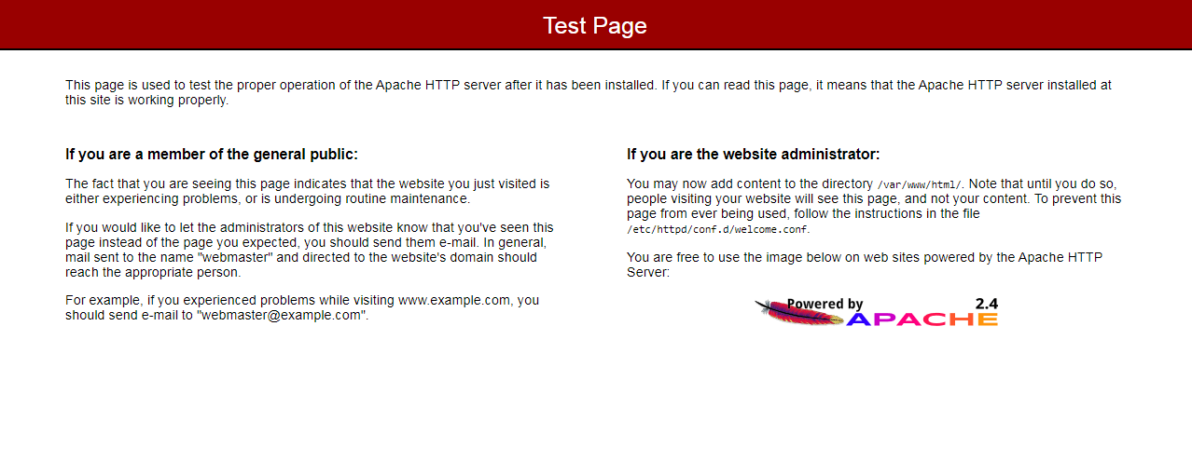

**[root@tomcat ~]# ls**

**apache-tomcat-10.1.18.tar.gz**

**[root@tomcat ~]# tar -xvf apache-tomcat-10.1.18.tar.gz**

**[root@tomcat ~]# ls**

**apache-tomcat-10.1.18 apache-tomcat-10.1.18.tar.gz**

**[root@tomcat ~]# cd apache-tomcat-10.1.18/**

**[root@tomcat apache-tomcat-10.1.18]# ls**

**bin BUILDING.txt conf CONTRIBUTING.md lib LICENSE logs NOTICE README.md RELEASE-NOTES RUNNING.txt temp webapps work**

**[root@tomcat apache-tomcat-10.1.18]# ll**

**total 128**

**drwxr-x--- 2 root root 4096 Feb 11 10:10 bin**

**-rw-r----- 1 root root 20437 Jan 5 14:39 BUILDING.txt**

**drwx------ 2 root root 238 Jan 5 14:39 conf**

**-rw-r----- 1 root root 6210 Jan 5 14:39 CONTRIBUTING.md**

**drwxr-x--- 2 root root 4096 Feb 11 10:10 lib**

**-rw-r----- 1 root root 60393 Jan 5 14:39 LICENSE**

**drwxr-x--- 2 root root 6 Jan 5 14:39 logs**

**-rw-r----- 1 root root 2333 Jan 5 14:39 NOTICE**

**-rw-r----- 1 root root 3398 Jan 5 14:39 README.md**

**-rw-r----- 1 root root 6776 Jan 5 14:39 RELEASE-NOTES**

**-rw-r----- 1 root root 16076 Jan 5 14:39 RUNNING.txt**

**drwxr-x--- 2 root root 30 Feb 11 10:10 temp**

**drwxr-x--- 7 root root 81 Jan 5 14:39 webapps**

**drwxr-x--- 2 root root 6 Jan 5 14:39 work**

**[root@tomcat apache-tomcat-10.1.18]# cd bin/**

**[root@tomcat bin]# ll**

**total 992**

**-rw-r----- 1 root root 36124 Jan 5 14:39 bootstrap.jar**

**-rw-r----- 1 root root 15127 Jan 5 14:39 catalina.bat**

**-rwxr-x--- 1 root root 23445 Jan 5 14:39 catalina.sh**

**-rw-r----- 1 root root 1664 Jan 5 14:39 catalina-tasks.xml**

**-rw-r----- 1 root root 2123 Jan 5 14:39 ciphers.bat**

**-rwxr-x--- 1 root root 1997 Jan 5 14:39 ciphers.sh**

**-rw-r----- 1 root root 25661 Jan 5 14:39 commons-daemon.jar**

**-rw-r----- 1 root root 214214 Jan 5 14:39 commons-daemon-native.tar.gz**

**-rw-r----- 1 root root 2040 Jan 5 14:39 configtest.bat**

**-rwxr-x--- 1 root root 1922 Jan 5 14:39 configtest.sh**

**-rwxr-x--- 1 root root 8319 Jan 5 14:39 daemon.sh**

**-rw-r----- 1 root root 2091 Jan 5 14:39 digest.bat**

**-rwxr-x--- 1 root root 1965 Jan 5 14:39 digest.sh**

**-rw-r----- 1 root root 3606 Jan 5 14:39 makebase.bat**

**-rwxr-x--- 1 root root 3382 Jan 5 14:39 makebase.sh**

**-rw-r----- 1 root root 2096 Jan 5 14:39 migrate.bat**

**-rwxr-x--- 1 root root 1970 Jan 5 14:39 migrate.sh**

**-rw-r----- 1 root root 3382 Jan 5 14:39 setclasspath.bat**

**-rwxr-x--- 1 root root 3941 Jan 5 14:39 setclasspath.sh**

**-rw-r----- 1 root root 2020 Jan 5 14:39 shutdown.bat**

**-rwxr-x--- 1 root root 1902 Jan 5 14:39 shutdown.sh**

**-rw-r----- 1 root root 2022 Jan 5 14:39 startup.bat**

**-rwxr-x--- 1 root root 1904 Jan 5 14:39 startup.sh**

**-rw-r----- 1 root root 48715 Jan 5 14:39 tomcat-juli.jar**

**-rw-r----- 1 root root 539277 Jan 5 14:39 tomcat-native.tar.gz**

**-rw-r----- 1 root root 3623 Jan 5 14:39 tool-wrapper.bat**

**-rwxr-x--- 1 root root 4600 Jan 5 14:39 tool-wrapper.sh**

**-rw-r----- 1 root root 2026 Jan 5 14:39 version.bat**

**-rwxr-x--- 1 root root 1908 Jan 5 14:39 version.sh**

**[root@tomcat bin]# sh startup.sh**

**Using CATALINA_BASE: /root/apache-tomcat-10.1.18**

**Using CATALINA_HOME: /root/apache-tomcat-10.1.18**

**Using CATALINA_TMPDIR: /root/apache-tomcat-10.1.18/temp**

**Using JRE_HOME: /usr**

**Using CLASSPATH: /root/apache-tomcat-10.1.18/bin/bootstrap.jar:/root/apache-tomcat-10.1.18/bin/tomcat-juli.jar**

**Using CATALINA_OPTS:**

**Tomcat started.  
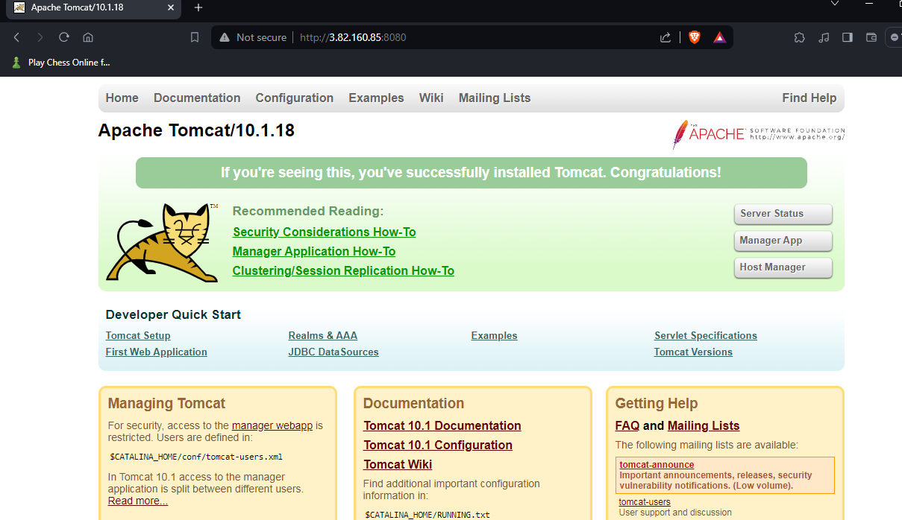**

**[root@tomcat bin]# sh shutdown.sh**

**Using CATALINA_BASE: /root/apache-tomcat-10.1.18**

**Using CATALINA_HOME: /root/apache-tomcat-10.1.18**

**Using CATALINA_TMPDIR: /root/apache-tomcat-10.1.18/temp**

**Using JRE_HOME: /usr**

**Using CLASSPATH: /root/apache-tomcat-10.1.18/bin/bootstrap.jar:/root/apache-tomcat-10.1.18/bin/tomcat-juli.jar**

**Using CATALINA_OPTS:**

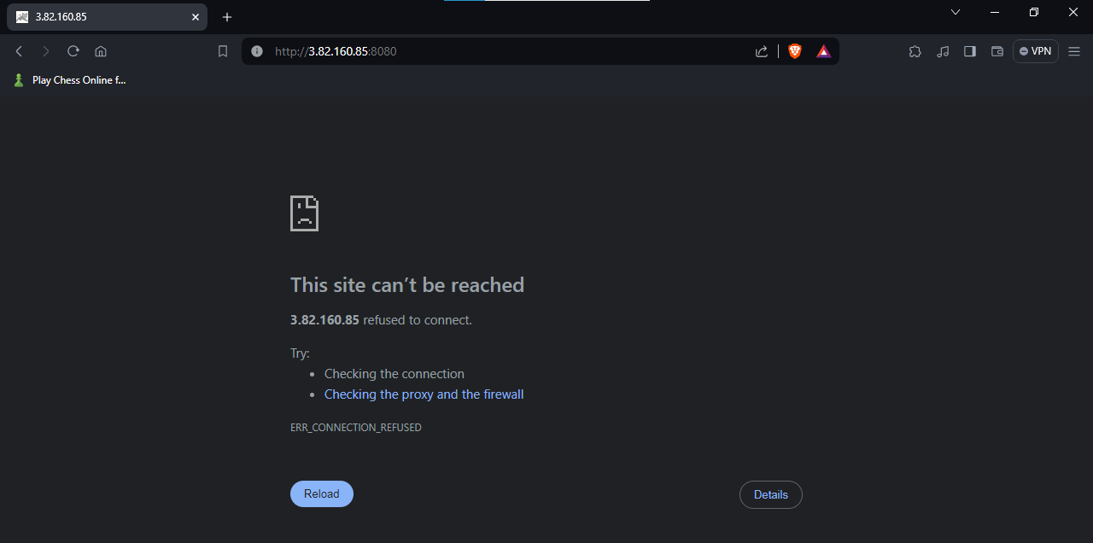

**[root@tomcat bin]#**

**Assignment 2.**

Enable CloudTrail, Create an SNS notification for CloudTrail events

Upload the final output Screenshot

**Assignment 3.**

Implement Auto Scaling: Create an Auto Scaling group that automatically launches new EC2 instances based on predefined rules. You can use the EC2 instance that you created in Task 1 as the base instance for the Auto Scaling group. Test the Auto Scaling group by simulating a surge in traffic to the web server.

Screenshot

**Assignment 4**

**Creating a Custom Amazon Machine Image (AMI)**

**- Launch a New EC2 Instance**

**- Install http on the new instance, enable the http service to start at boot.**

**- Create a New AMI from customized instance and name the AMI MicroDegreeWeb**

**- Launch a New Instance Using the Custom AM**

**- Verify that http is running.**

**Upload the final output Screenshot**

**Assignment 5**

Set up a basic EC2 instance: Create an Amazon Elastic Compute Cloud (EC2) instance and configure it to run a web server. You can choose any Linux-based operating system and web server software of your choice. Once the instance is up and running, access it using SSH and verify that the web server is serving web pages.

Upload the final output Screenshot

**Assignment 6**

Open putty, connect public IP and run some commands and show the output. Create Empty file, add some content and edit it in Vim.

Upload the final output Screenshot

**Assignment 7**

Build a custom docker image using Ubuntu as a base docker image and run the nginx application. - this docker image should be built using a Dockerfile. Once the docker image is build, start the docker image using the host network and make it accessible on Public IP

Upload the final output Screenshot

**Assignment 8**

Create 2 VPC's Named "Webapp-VPC" & "Db-VPC"

It should have 2 Subnets each, one with Class A IPv4 CIDR and Class B IPv4 CIDR, and 255 ports in each subnet.

Screenshot :

**Assignment 9**

Create and configure an S3 bucket: Create a new Amazon Simple Storage Service (S3) bucket and configure it for static website hosting. Then, upload a sample HTML file and ensure that it can be accessed through a web browser.

Screenshot

**Assignment 10**

**Creating a Docker Compose Configuration:**

**Write a Docker Compose YAML file (docker-compose.yml) to define a multi-container application setup.**

**Specify the services, their configurations, and any necessary links or dependencies between containers.**

**Use the docker-compose up command to start the containers defined in the Docker**

**Upload the final output Screenshot**

**Assignment 11**

Install and configure jenkins on a server, and create a new jenkins job and configure its parameters.

Upload the final output Screenshot

**Assignment 12**

Setting Up Continuous Integration and Deployment (CI/CD):

Jenkins is often used for implementing CI/CD pipelines to automate the build, test, and deployment processes.Create a pipeline job using Jenkins Pipeline DSL (declarative or scripted) or a Jenkins file.

Define the stages of your pipeline, including building, testing, code analysis, and deployment.  
Configure Jenkins to trigger the pipeline based on code changes, commits, or other events.

Screenshot

**Assignment 13**

Working with Docker Images

- Pull the latest `httpd` image.

- Pull the latest `alpine` image.

- verify images pulled and create 2 containers in each server

Upload the final output Screenshot  
  
 **Assignment 14**

Create a Staging branch in GitHub and push code from the local repository to the Remote and share the full commands screen

Screenshot:

**Assignment 15**

Scenario:A user reports that they are unable to access a website by its domain name, but other websites are working fine. What steps would you take to troubleshoot and resolve this issue from the DNS perspective?

Explain in 300 words